Closure Takeaway Grid Guidelines  • As a school we want to offer your child the opportunity to continue to learn whilst away from the classroom over the coming weeks.  • The Takeaway is designed to give you the opportunity to promote learning at home in a fun and interactive way.  • All tasks are designed to consolidate the learning that has taken place so far this school year.  • There is a mix of English, Maths and Topic tasks that your child can choose from.  • Tasks are optional. As few or many tasks can be completed as desired.  • When a task is completed, please colour the square.  • Some tasks may ask for evidence (a photo, drawing or piece of writing) - when your child returns to school, please hand in the takeaway and any evidence of work. Alternatively, you can send these through to the class teacher via email or Class Dojo.  • Please also see the list of useful websites that can be used to support your child’s learning. | Closure Takeaway Grid  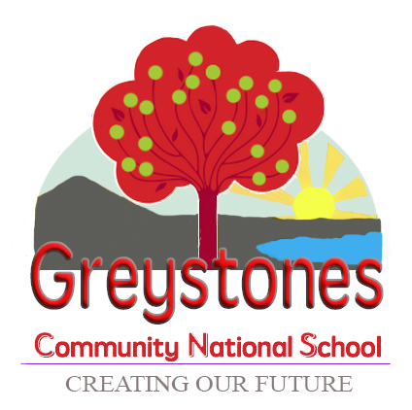  Home-School learning collaboration to support your child during their time away from school.

Write a shopping list | Play a game of snap or another card game |  | Do some planting | Draw a cartoon comic strip
Design a new cover for your favourite book | Go on a shape hunt, find circles, squares, triangles, rectangles |  | Draw the stages of a plant growing from seed to flower | Practise skipping
Draw and label your favourite farm animal | Create some patterns using toys/beads/lego |  | Sort your toys by colour | Help set the table for a family meal
Play ‘I Spy’ | Hide a toy and design a treasure map to find it |  | Recite some Gaeilge rhymes | Paint/draw a farm scene

