Closure Takeaway Grid Guidelines  • As a school we want to offer your child the opportunity to continue to learn whilst away from the classroom over the coming weeks.  • The Takeaway is designed to give you the opportunity to promote learning at home in a fun and interactive way.  • All tasks are designed to consolidate the learning that has taken place so far this school year.  • There is a mix of English, Maths and Topic tasks that your child can choose from.  • Tasks are optional. As few or many tasks can be completed as desired.  • When a task is completed, please colour the square.  • Some tasks may ask for evidence (a photo, drawing or piece of writing) - when your child returns to school, please hand in the takeaway and any evidence of work. Alternatively, you can send these through to the class teacher via email or Class Dojo.  • Please also see the list of useful websites that can be used to support your child’s learning. | Closure Takeaway Grid  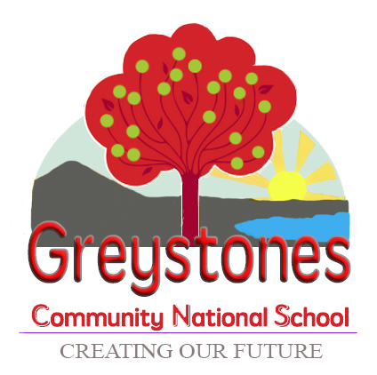  Home-School learning collaboration to support your child during their time away from school.

Literacy  Do some rainbow writing of the words you know | Maths  Practice counting objects into groups of 20 |  | Topic  Use old magazines/newspapers to create a collage | Fun  Get active:  Jumping jacks, Skipping  Throwing and catching  Hopping, yoga
Design and create a Spring picture Book | Set up a shop in your kitchen |  | Watch something on Cúla 4/TG4 | Build a fort/tent in your room & Read a book
Draw/Paint your favourite Roald Dahl Character | Tidy your bedroom & sort your toys by size |  | Draw some Spring Pictures & label the pictures | Follow a simple recipe to make a healthy snack
Recall and perform all the poems & Rhymes from this year | Roll a dice and add the numbers together |  | Draw a map of your bedroom/house/garden/locality | Create a diorama inside a shoebox

