Closure Takeaway Grid Guidelines  • As a school we want to offer your child the opportunity to continue to learn whilst away from the classroom over the coming weeks.  • The Takeaway is designed to give you the opportunity to promote learning at home in a fun and interactive way.  • All tasks are designed to consolidate the learning that has taken place so far this school year.  • There is a mix of English, Maths and Topic tasks that your child can choose from.  • Tasks are optional. As few or many tasks can be completed as desired.  • When a task is completed, please colour the square.  • Some tasks may ask for evidence (a photo, drawing or piece of writing) - when your child returns to school, please hand in the takeaway and any evidence of work. Alternatively, you can send these through to the class teacher via email or Class Dojo.  • Please also see the list of useful websites that can be used to support your child’s learning. | Closure Takeaway Grid  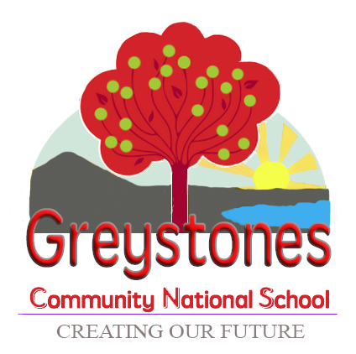  Home-School learning collaboration to support your child during their time away from school.

If the answer was 15, what could the question be? Make 5 word  problems. | Write an adventure story, where the main  character is you! |  | Label 10 items at home ‘as Gaeilge’ (in Irish). Take a photo. | Help at home!—do five things around the house (e.g. tidy room, set the  table, make a bed, wash dishes)
Find five containers in the house. Estimate and  measure how much  water they can hold. | Write an acrostic poem all about Spring. |  | Play Bingo using the  numbers 1—10 ‘as Gaeilge’. | Following a recipe,  measure ingredients and make a delicious dish!
Go for a walk and tally how many spring animals or flowers you see. | Read a book each day and retell the story in your own words. |  | Tune in to RTE Junior (www.rtejr.rte.ie) and watch ‘10 @ 10’ or ’Twigín Yoga’ as Gaeilge. | Look up ‘Go Noodle Get Moving’ on YouTube—do a work out each  morning!
Play / Make a board game that involves counting to 50. (snakes and ladders is a good one!) | Keep a diary / journal for 5 days of your time away from school—what did you do? Where did you go? |  | Take photos of 10 signs in Greystones that are written in both Irish and English. | Make a piece of artwork that represents Spring time.

